1. **CORS**:
   1. **C**ross-**O**rigin **R**esource **S**haring.
   2. It means applications with two different origins are trying to communicate with each other.
2. **Agenda**: Let’s see CORS in more detail in this lecture.
3. 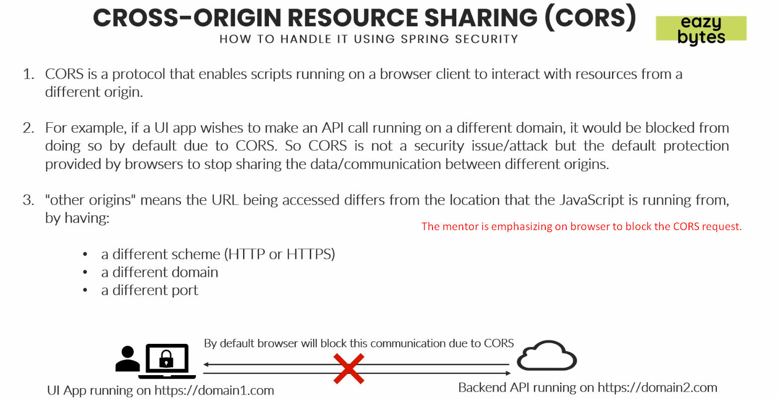
4. 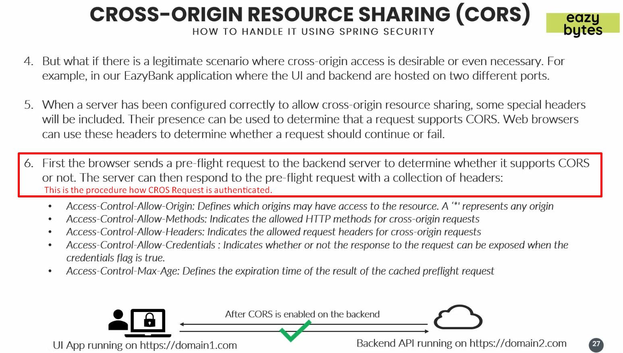
5. Let’s make configurations on the server side so that these above parameters can be set the pre-flight request and communication can be allowed by the browser b/w two different origins.
6. Let’s do this in next